Lake Mungo
This site is the remains of a dried up Lake in Australia. Its location is a few kilometers from Sydney in the west-central part of the New South Wales. The site is said to have been home to the Aboriginal people who buried their dead on the dried lake bed over 40,000 years ago. The alkalinity of the soil helped preserve remains known to be the oldest in Australia.
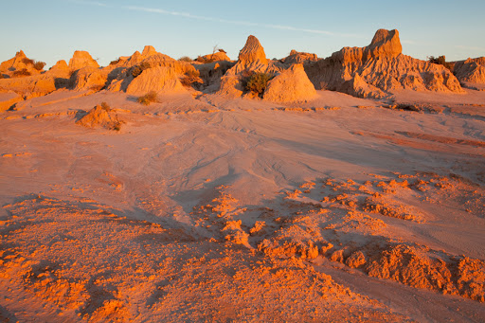
Sources
Bhandari, S. (2017). Lake Mungo [Photograph]. https://stillunfold.com/history/the-archaeological-history-of-lake-mungo
Britannica, T. Editors of Encyclopedia (2020, November 10). Lake Mungo. Encyclopedia Britannica. https://www.britannica.com/place/Lake-Mungo
Göbekli Tepe
The site is a sanctuary located in the province of Sanliurfa, Turkey. The site location is on top of Girê Mirazan Hill, opposite the Harran plains and at the foot of the Taurus Mountains. The site dates back to the pre-pottery Neolithic period and was at its height around 10BCE when people of the Neolithic culture started developing permanent settlements.
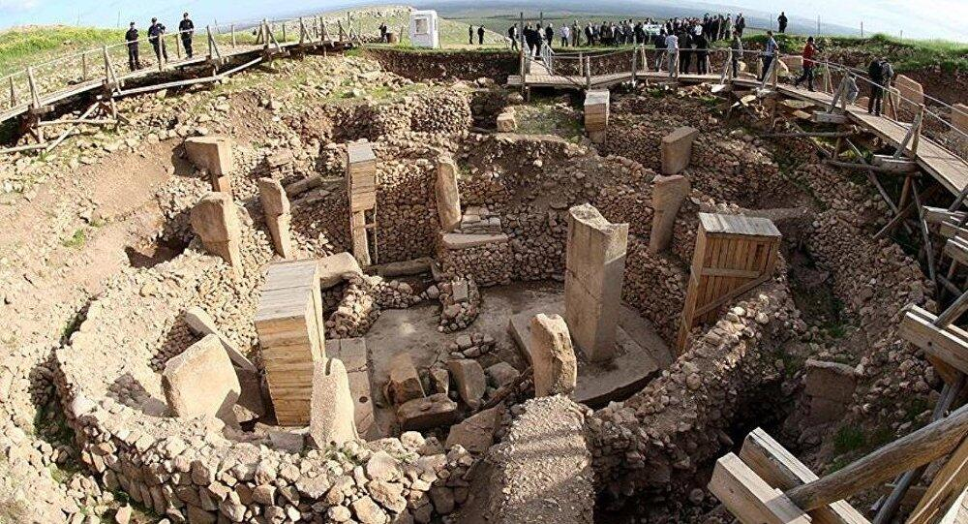
Sources
Curry, A. (2008, November 1). Gobekli Tepe: The World’s First Temple? Smithsonian Magazine. https://www.smithsonianmag.com/history/gobekli-tepe-the-worlds-first-temple-83613665/
News, H. (2018, July 2). Turkey's Göbeklitepe UNESCO heritage site. Hürriyet Daily News [Photograph]. https://www.hurriyetdailynews.com/turkeys-gobeklitepe-added-to-unesco-heritage-list-134048
Nazca Lines
The site consists of a huge geoglyph found in the Nazca Desert. The site is found in Republic of Peru which is in the Western Part of South America. The people who are believed to have created the geoglyphs were of the Nazca culture around 800AD.
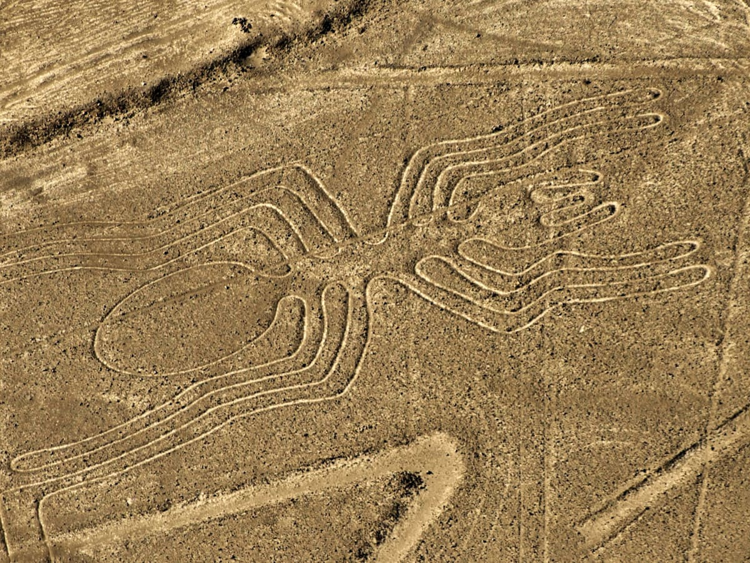
Sources
History.com Editors. (2018, August 21). Nazca Lines. HISTORY[Photograph]. https://www.history.com/topics/south-america/nazca-lines
Knudson et al. (2009). “The geographic origins of Nazca trophy heads using strontium, oxygen, and carbon isotope data.” Journal of Anthropological Archaeology.

Angkor Wat
The site is a large Hindu temple located in Siem Reap city in the Northern part of Cambodia built around the early 1100s. The inhabitants were the Khmer people of the Buddhist culture. The site is located on a plain and wet area to the North of Tonle Sap Lake. The site was at its height between 9-15BC when it was used as a capital city by the Khmer people.
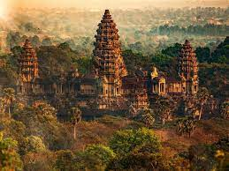
Sources
Learn, J. R. (2020, February 21). Angkor Wat. Smithsonian Magazine [photograph]. https://www.smithsonianmag.com/history/angkor-wat-reservoir-engineering-catastrophe-180974227/
Ray, Nick. “Angkor what? Getting to know Cambodia’s most iconic temple.” LonelyPlanet.com.
Ġgantija, Malta
The site consists of two Megalithic temples standing on the Xaghra plateau located in Gozo Island, Malta. The temples are said to have been used by the people of the Gozitan culture to perform prayer rituals on fertility of land, animals and women. The temples were in use around 3600-2500BC.
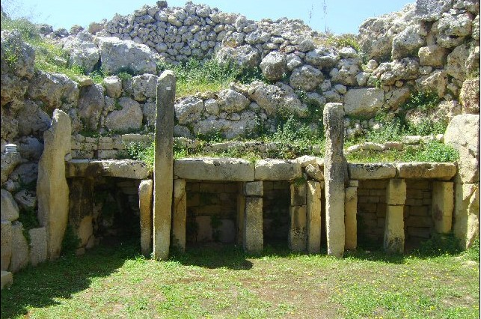
Sources
Hisour. (2020, July 5). Ggantija Temples, Ix-Xaghra, Malta. HiSoUR - Hi So You Are [Photograph]. https://www.hisour.com/ggantija-temples-ix-xaghra-malta-19027/
Whitaker, A. (n.d.). Ggantija, Malta. Ancient Wisdom. Retrieved August 6, 2021, from http://www.ancient-wisdom.com/maltagantuja.htm
Timbuktu, Mali
The site is a city located to the North of the Niger River and at the edge of the Sahara desert in Mali, West Africa. The Djingareyber Mosque, Sidi Yahia Mosque, and the Sankore Mosque signify the city as a holy place for the inhabitants who were o the Islamic culture. The city is still in use, though the ancient structures have aged and require maintenance.
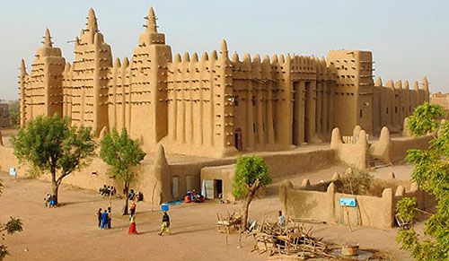
Sources
Trigueros, F. (2020, August 11). Timbuktu. Reimagine [Photograph]. https://reimagineoc.org/event/reimagine-virtual-class-2-2-2020-08-11-2020-08-25-2020-09-29/
UNESCO World Heritage Centre. (2021). Timbuktu. https://whc.unesco.org/en/list/119/

Ghazni
The site is a city located in a plateau to the South of Kabul, Afghanistan. The city can be easily accessed from Iran, Central Asia, and India. The city is rich in Islamic culture and some artifacts found in the region are said to be Buddhist. The Islamic culture in the city dates back to the early 7th century and has been part of a number of wars and conquests.
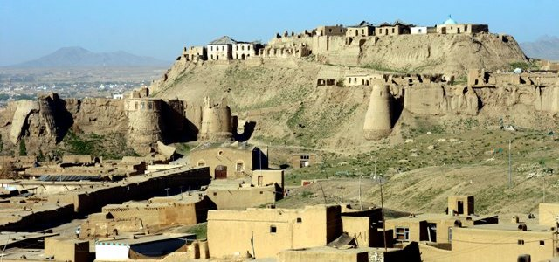
Sources
Giunta, R. (2005). Islamic Ghazni An IsIAO Archaeological Project in Afghanistan: A Preliminary Report (July 2004-June 2005). JSTOR. https://www.jstor.org/stable/29757660
Image source: https://www.afghanzariza.com/2015/04/08/ghazni-the-city-of-diverse-islamic-architecture

Oldupai Gorge
The site consists of a gorge within the Rift Valley of Eastern Africa in Tanzania. The site is located in Arusha, within the plains of Serengeti. The site marks Africa as the cradle of mankind as the earliest human remains were excavated from the gorge. The name originates from the Maasai culture. The site was at its height during the pre-colonial period in East Africa, when scientists were still fascinated by the discovery of the Rift Valley.
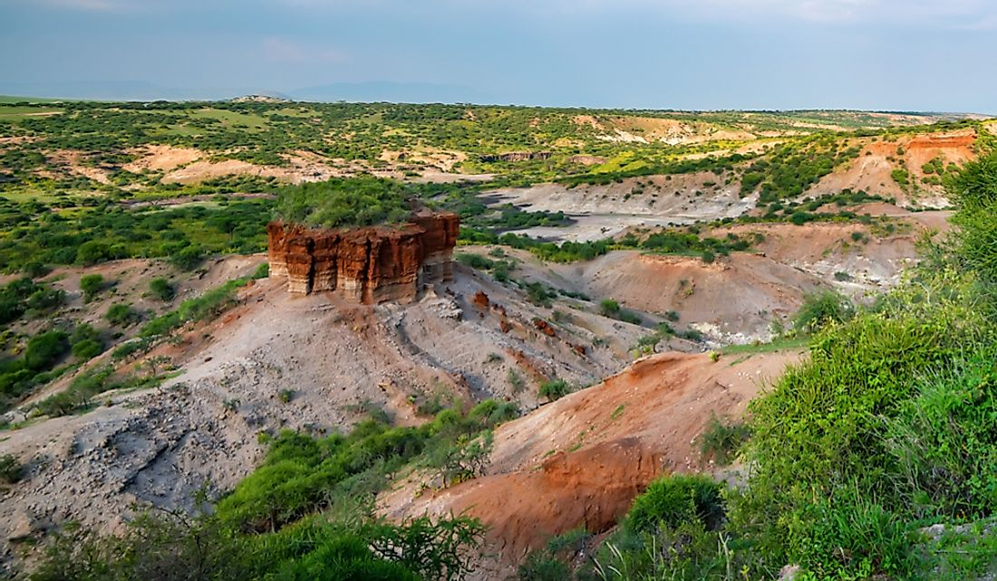
Sources
Hay, R. L. (1976). Geology of the Olduvai Gorge. Рипол Классик. Oldupai Gorge
Owuor, S. (2019, February 1). Where Is The Olduvai Gorge Located And Why Is It Important? WorldAtlas [Photograph]. https://www.worldatlas.com/articles/where-is-the-olduvai-gorge-located-and-why-is-it-important.html
Ziggurat of Ur
The site is located in Tell el-Muqayyar town, formerly known as Ur, in the province of Dhi Qar found in Iraq. The site is not so far from River Euphrates. The Sumerian structure was built in the 21century BC in reverence to the god of the moon known as Nannar. The original construction was ruined but later reconstructed in the 1930s. The structure represents the Sumerian culture, which vanished with the fall of Ur.
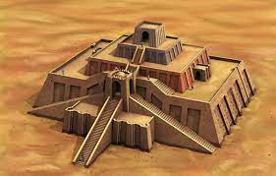
Sources
Germaan, S. (2021). Ziggurat of Ur (article) | Ancient Near East. Khan Academy. Ziggurat of Ur
Image source: https://www.ancient-origins.net/ancient-places-asia/great-ziggurat-ur-001767
Pompeii
The archeological site of Pompeii contains remnants of an ancient Roman city destroyed by a volcanic eruption in the late 70s AD. The site is located on the southern part of Italy, near Naples. The ancient city is situated to the North of the Vesuvius Mountain. Pompeii was at its height in 8th century AD when it was a port town and a vacation center for many. The site still remains a symbol of the Roman culture.
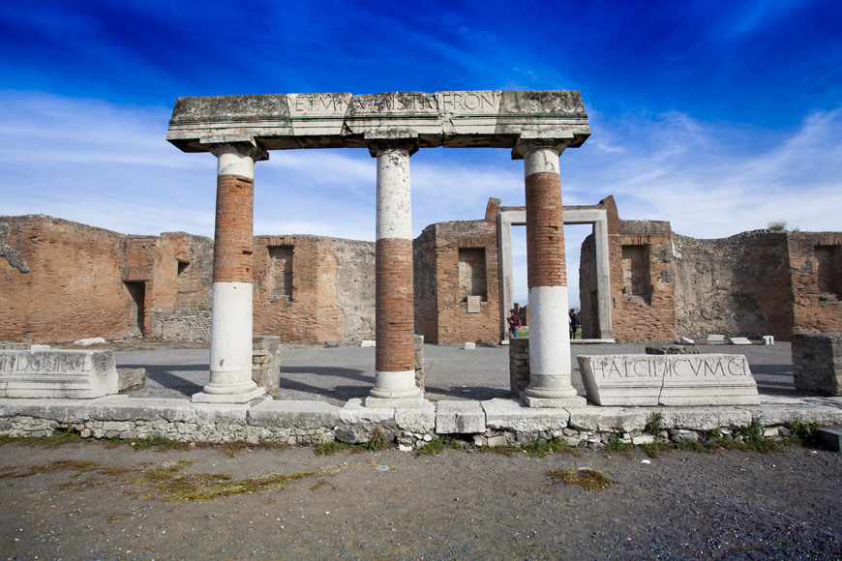
Source
Bianchini, R. (2019, November 1). Pompeii archaeological site. Inexhibit. https://www.inexhibit.com/mymuseum/pompeii-archaeological-site-naples/

Chaco Canyon
The Chaco Canyon is located within the Chaco Culture National Historical Park in the United States. The site is found in the high desert region of the north-western part of New Mexico and is characterized by water scarcity. The canyon is rich in representations of the Pueblo culture. The canyon was used as a cultural center by ancient Puebloans in the years between 900-1150 AD.
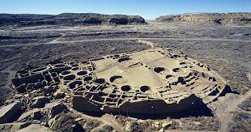
Sources
Image source: https://whc.unesco.org/en/list/353/
Kilroy-Ewbank, L. (2021). Chaco Canyon (article). Khan Academy. https://www.khanacademy.org/humanities/art-americas/early-cultures/ancestral-puebloan/a/chaco-canyon

Lascaux Cave
The site is a Paleolithic cave located in the south-western part of France, close to Montignac village within the Dordogne region. The site is home to various prehistoric cave wall paintings. The paintings are dated back to the early Stone Age with research showing that the paintings were made by the homo habilis as representations of the things around them.
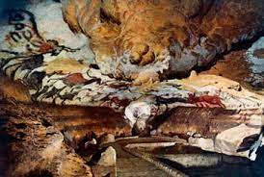
Sources
Groeneveld, E. (2016, August 5). Lascaux Cave. World History Encyclopedia. https://www.worldhistory.org/Lascaux_Cave/
Image source: https://edu.rsc.org/resources/dangers-to-cave-art/1547.article

